**Exp. 1 Design Christmas dual led chaser lights.**

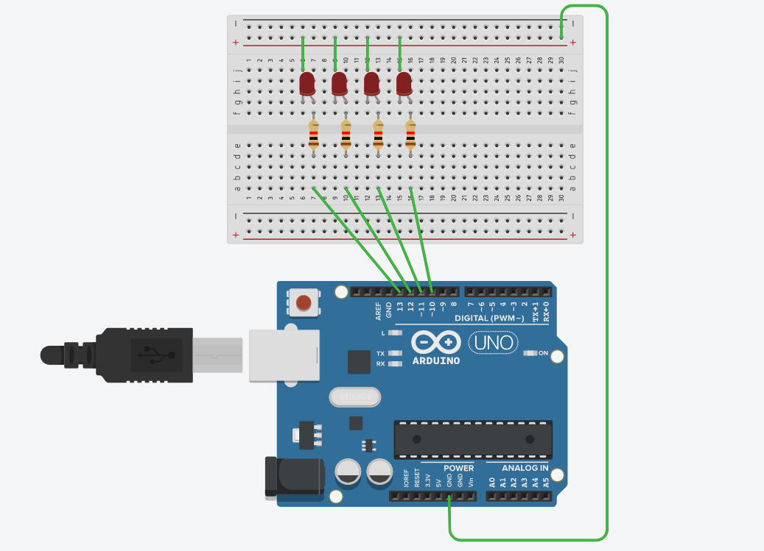

**Circuit Diagram:**

**ABOUT LED CHASER:**  Led Chaser is a circuit which blinks LEDs in a particular frequency and particular pattern so that it provides the effect of illusion, LED are moving. These LED chasers are used in decorative lighting. The LEDs lights one by one for a period of 1second and the cycle repeats giving the running light appearance.

**Theory:** 555 timer IC. The 555 timer IC is an integrated circuit (chip) used in a variety of timer, pulse generation, and oscillator applications. The 555 can be used to provide time delays, as an oscillator, and as a flip-flop element. Derivatives provide two (556) or four (558) timing circuits in one package.

**FOR CONSTRUCTION OBJECT REQUIRED:**

1. NEED FOUR LED
2. BREAD BOARD
3. ARDUINO
4. FOUR WIRES TO CONNECT LED WITH ARDUINO AND ONE WIRE FOR GROUNDING.

**ABOUT 555 TIMER IC:**

555 timer IC The 555 timer chip, or integrated circuit, as it’s formally known is very commonly used in many electronic circuits as a basis up on which an engineer can build on. Not only is the 555 timer chip very versatile, but it is very cheap. As you can see from the diagram below, the 555 timer chip has 8 pins, each of which provides a means of functionality. Throughout this section, I will label and describe how each pin works, and what it will be used for in this circuit.

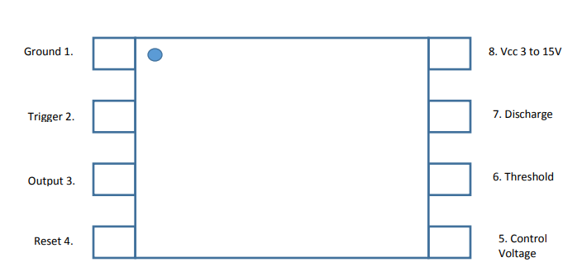

**WORKING OF EACH PIN IN CIRCUIT:**

* **Pin 1, Ground:** As it states; the ground connects the 555 timer chip to the negative power rail, thus the voltage is 0.
* **Pin 2, Trigger:** This essentially, as stated by the name is the “trigger” of the timing cycle. When the voltage across the pin is below 1 3 of the rail voltage, basically the supply voltage, then the output from pin 3 will be high, which in terms of binary is on, or 1.
* **Pin 3, Output:** As it states in the name, pin 3 is the output, this of which leads to the 4017 counter IC.
* **Pin 4, Reset:** Pin 4 acts as a reset switch for the timing operation. If the reset pin is momentarily grounded, the timing operation is halted, and it will only return to its timing operation when the trigger activates it. This pin is connected to the supply voltage.
* **Pin 5, Control voltage:** As stated by the name of the pin, this particular pin controls the voltage in case there any fluctuations in the voltage. The controlling of fluctuations can be rectified by adding a capacitor in series between the control pin, and the ground. I won’t use this pin, as I will just add a capacitor across the power supply rails. The schematic above will outline the details of this.
* **Pin 6, Threshold:** The purpose of this pin is essentially to monitor the voltage levels across pin 7, discharge. When the voltage across pin 7 reaches 2 3 of the supply voltage, it will end the timing cycle, and the output from pin 3 will become low, 0.
* **Pin 7, Discharge:** This pin works in terms of monitoring the discharge voltage from an external capacitor. Usually, the capacitor is connected to ground, and the resistor is connected to the supply voltage. The resistor and capacitor form an RC circuit, which acts as a timing interval.
* **Pin 8, Vcc 3 to 15V:** Pin 8 connects the 555 timer chip to the supply voltage; this can range from as little as 3V, to the larger extent of 15V. The circuit that I am using will supply the 555 timer with 9V.

**Learning & Observation:**

1. Working of LED chaser.
2. Code for Arduino to Run LED Chaser.

**Precautions:**

1. There should not be any loose connection in the circuit.
2. Code should be written properly.
3. Arduino should be attached to pc/laptop properly.

**Code:**

void setup(){

// setting up output pins

for (int i = 10; i <= 13; i++) {

pinMode(i, OUTPUT);

}

}

void loop(){

for (int i = 10; i <14; i++) {

allLEDsOff();

if (i!=13){

digitalWrite(i,HIGH);

digitalWrite(i+1,HIGH);

delay(200);

}

else

digitalWrite(i,HIGH);

digitalWrite(i-3,HIGH);

delay(200);

allLEDsOff();

}

}

void allLEDsOff(void)

{

for (int i = 10; i <= 14; i++) {

digitalWrite(i, LOW);

}

delay(100);

}